**Chapter 5**

**5.1 Introduction:**

In this chapter, we will draw the class diagram to design our application, as well as additional diagrams we chose that are relevant and appropriate for our application.

**5.2 Class Diagram:**

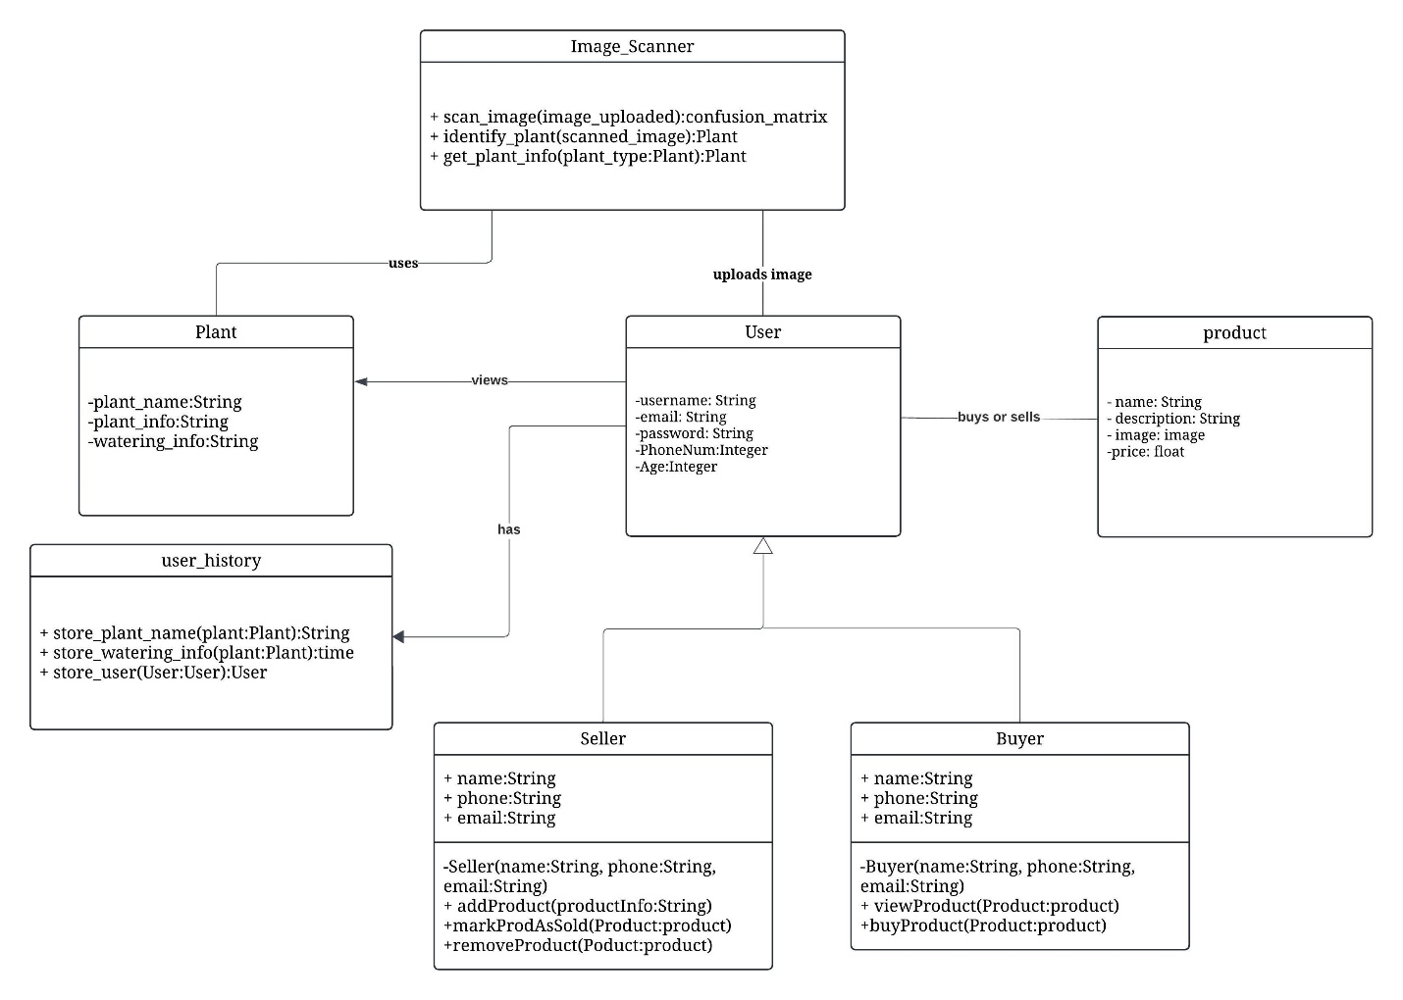

**5.3 Activity Diagram:**

**5.4 Conclusion:**

In this chapter, we modeled a class diagram and an activity diagram that were suitable for our project.